Lecture 9



In chapter 24:

- the charge resides on the conductor’s outer surface.

- The electric field just outside the conductor is perpendicular to the surface and the field inside is zero

What’s about electric potential?

Consider two points A and B on the surface of a charged conductor as shown in Figure 25.17.

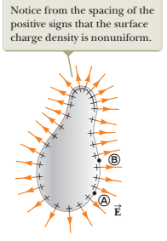 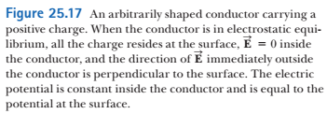

Since E is perpendicular to the surface, it is perpendicular to the displacement $\vec{ds}$; Hence

$\vec{E} ∙ \vec{ ds}=0$

Potential difference between points B and A is:

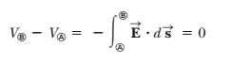

Since these points are arbitrary, potential on the conductor’s surface is constant

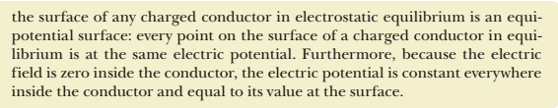

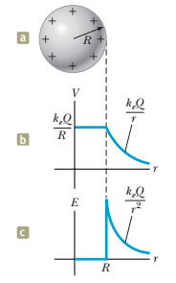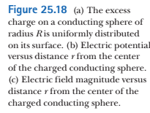

Consider a solid metal conducting sphere of radius *R* and total positive charge *Q* as shown in Figure 25.18a

Outside the sphere the electric field is $\vec{E }=kQ\hat{r}/r^{2}$

(the same as of a point charge)

The potential also should be the same as of a point charge: V = kQ/r

At the surface of the conducting sphere in Figure 25.18a, the potential must be *keQ* /*R.*

Figure 25.18 shows the electric potential and electric field as a function of *r*,

If the conductor is non-spherical as in Figure 25.17, however, the surface charge density is high where the radius of curvature  
is small and low where the radius of curvature is large.



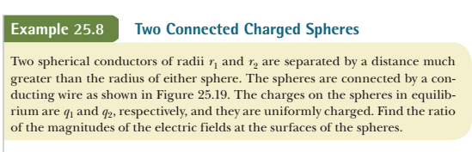

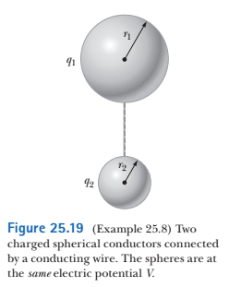

Solution:

The spheres have the same potential (they are connected with a wire)

 Hence



Electric fields at the surfaces of the spheres:



Hence,



and substituting q1/q2:



The field is stronger in the vicinity of the smaller sphere even though the electric potentials at the surfaces of both spheres are the same. If *r*2 -> 0, then , verifying the statement above that the electric field is very large at sharp points.



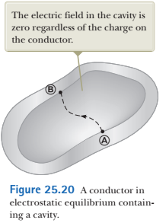

Consider a conductor of arbitrary shape with a cavity Let’s assume no charges are inside the cavity

the electric field inside the cavity must be *zero*



Because *V*B - *V*A = 0, the integral of $\vec{E} \vec{ds}$ must be zero for all paths between any two points A and B on the conductor.

“The only way that can be true for *all* paths is if **E**  is zero *everywhere* in the cavity.”



A phenomenon known as **corona discharge** is often observed near a conductor such as a high-voltage power line.

Consider a conductor that has a high electric potential. If the conductor has sharp, irregular edges, the electric field in the vicinity of these edges is high (because the curvature radius is small)

In the high electric field, air molecules get ionized. Free electrons accelerate in the electric field and collide with neutral molecules. Collisions result in ionization of neutral molecules and atoms.

<https://www.youtube.com/watch?v=POmmmCTQ4Xc>

<https://www.youtube.com/watch?v=IR5HykmiIxI>

<https://www.youtube.com/watch?v=CkjFJtMG5oY>



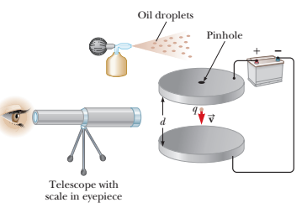

<https://www.youtube.com/watch?v=UFiPWv03f6g>

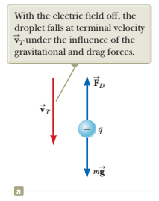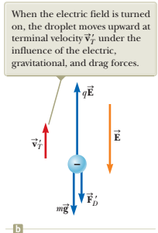









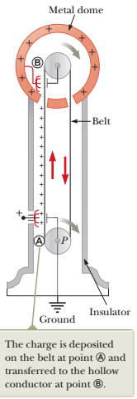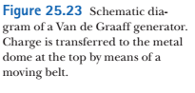

<https://www.youtube.com/watch?v=y20lKZB5BR0>



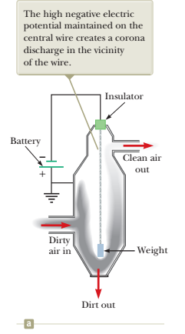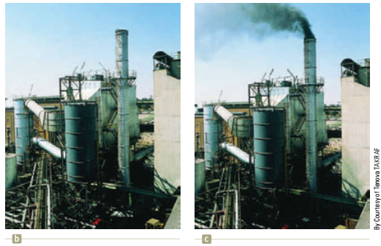

Central wire is negatively charged

it causes a corona discharge

particulates in the air het charged negatively in the current of e- and -ions toward the walls

particulates are drawn to the walls and form clusters



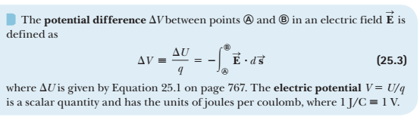

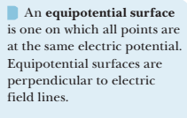

Potential energy change:



Potential due to a point charge:



if V(x) is a potential function, then the electric field is:



In the uniform electric field E potential difference between two points:



where d is distance between points

and vector **d** and **E** are colinear

Potential energy of a pair of point charges q1 and q2:



where r12 is a distance between charges

For continuous charge distribution, the electric potential is:

